ADVENT REFLECTION GUIDE

WHAT IS ADVENT?

The word Adventos means, “coming” or “arrival.” It has been recognized since the 4th century as a season of preparing, waiting, anticipating, and longing for God to reconcile all things. These cries have been going out since the early days of the Israelites who cried for a deliverer in the wilderness. Advent has become a time when we commemorate the arrival of Jesus and what that means for the world.

Advent also symbolizes the spiritual journey of individuals, as they affirm that Jesus has come and He is still present in our world today.

Advent is marked by prayers of humble receiving...of waiting and anticipation of new life. It is a time of joy and happiness as we await God’s Presence as it was manifested in the life of Jesus on earth.

ADVENT TRADITIONS

Advent begins with “hanging of the green”, boughs, and trees that symbolize life. The Advent wreath is a popular symbol of its beginning. It is a circular evergreen wreath (real or artificial) with five candles, four around the wreath and one in the center. It has become a vehicle to tell the Christmas story. The exact meaning given to the different aspects of the wreath is not as important as the story which it invites us to listen, and participate in. The circle of the wreath reminds us of God...with no beginning or end. The green of the wreath speaks of the newness of life. The candles symbolize the light coming into the world through the birth of Jesus. The four outer candles represent the period of waiting during the four weeks of Advent, which themselves symbolize the four centuries of waiting between the prophet Malachi and the birth of Jesus. The center candle represents Jesus.

In this reflection, I invite you to find a quiet place, perhaps light a candle... and prayerfully sit with the scripture verses, the journaling prompts and prayers, and the following words that will be highlighted in each reflection:

Faith and Hope—example, Mary
Humility —example, the Shepherds
Surrender—example, Joseph
Desperation—examples, the Wise Men
Desire—example, Jesus

THE FIRST REFLECTION
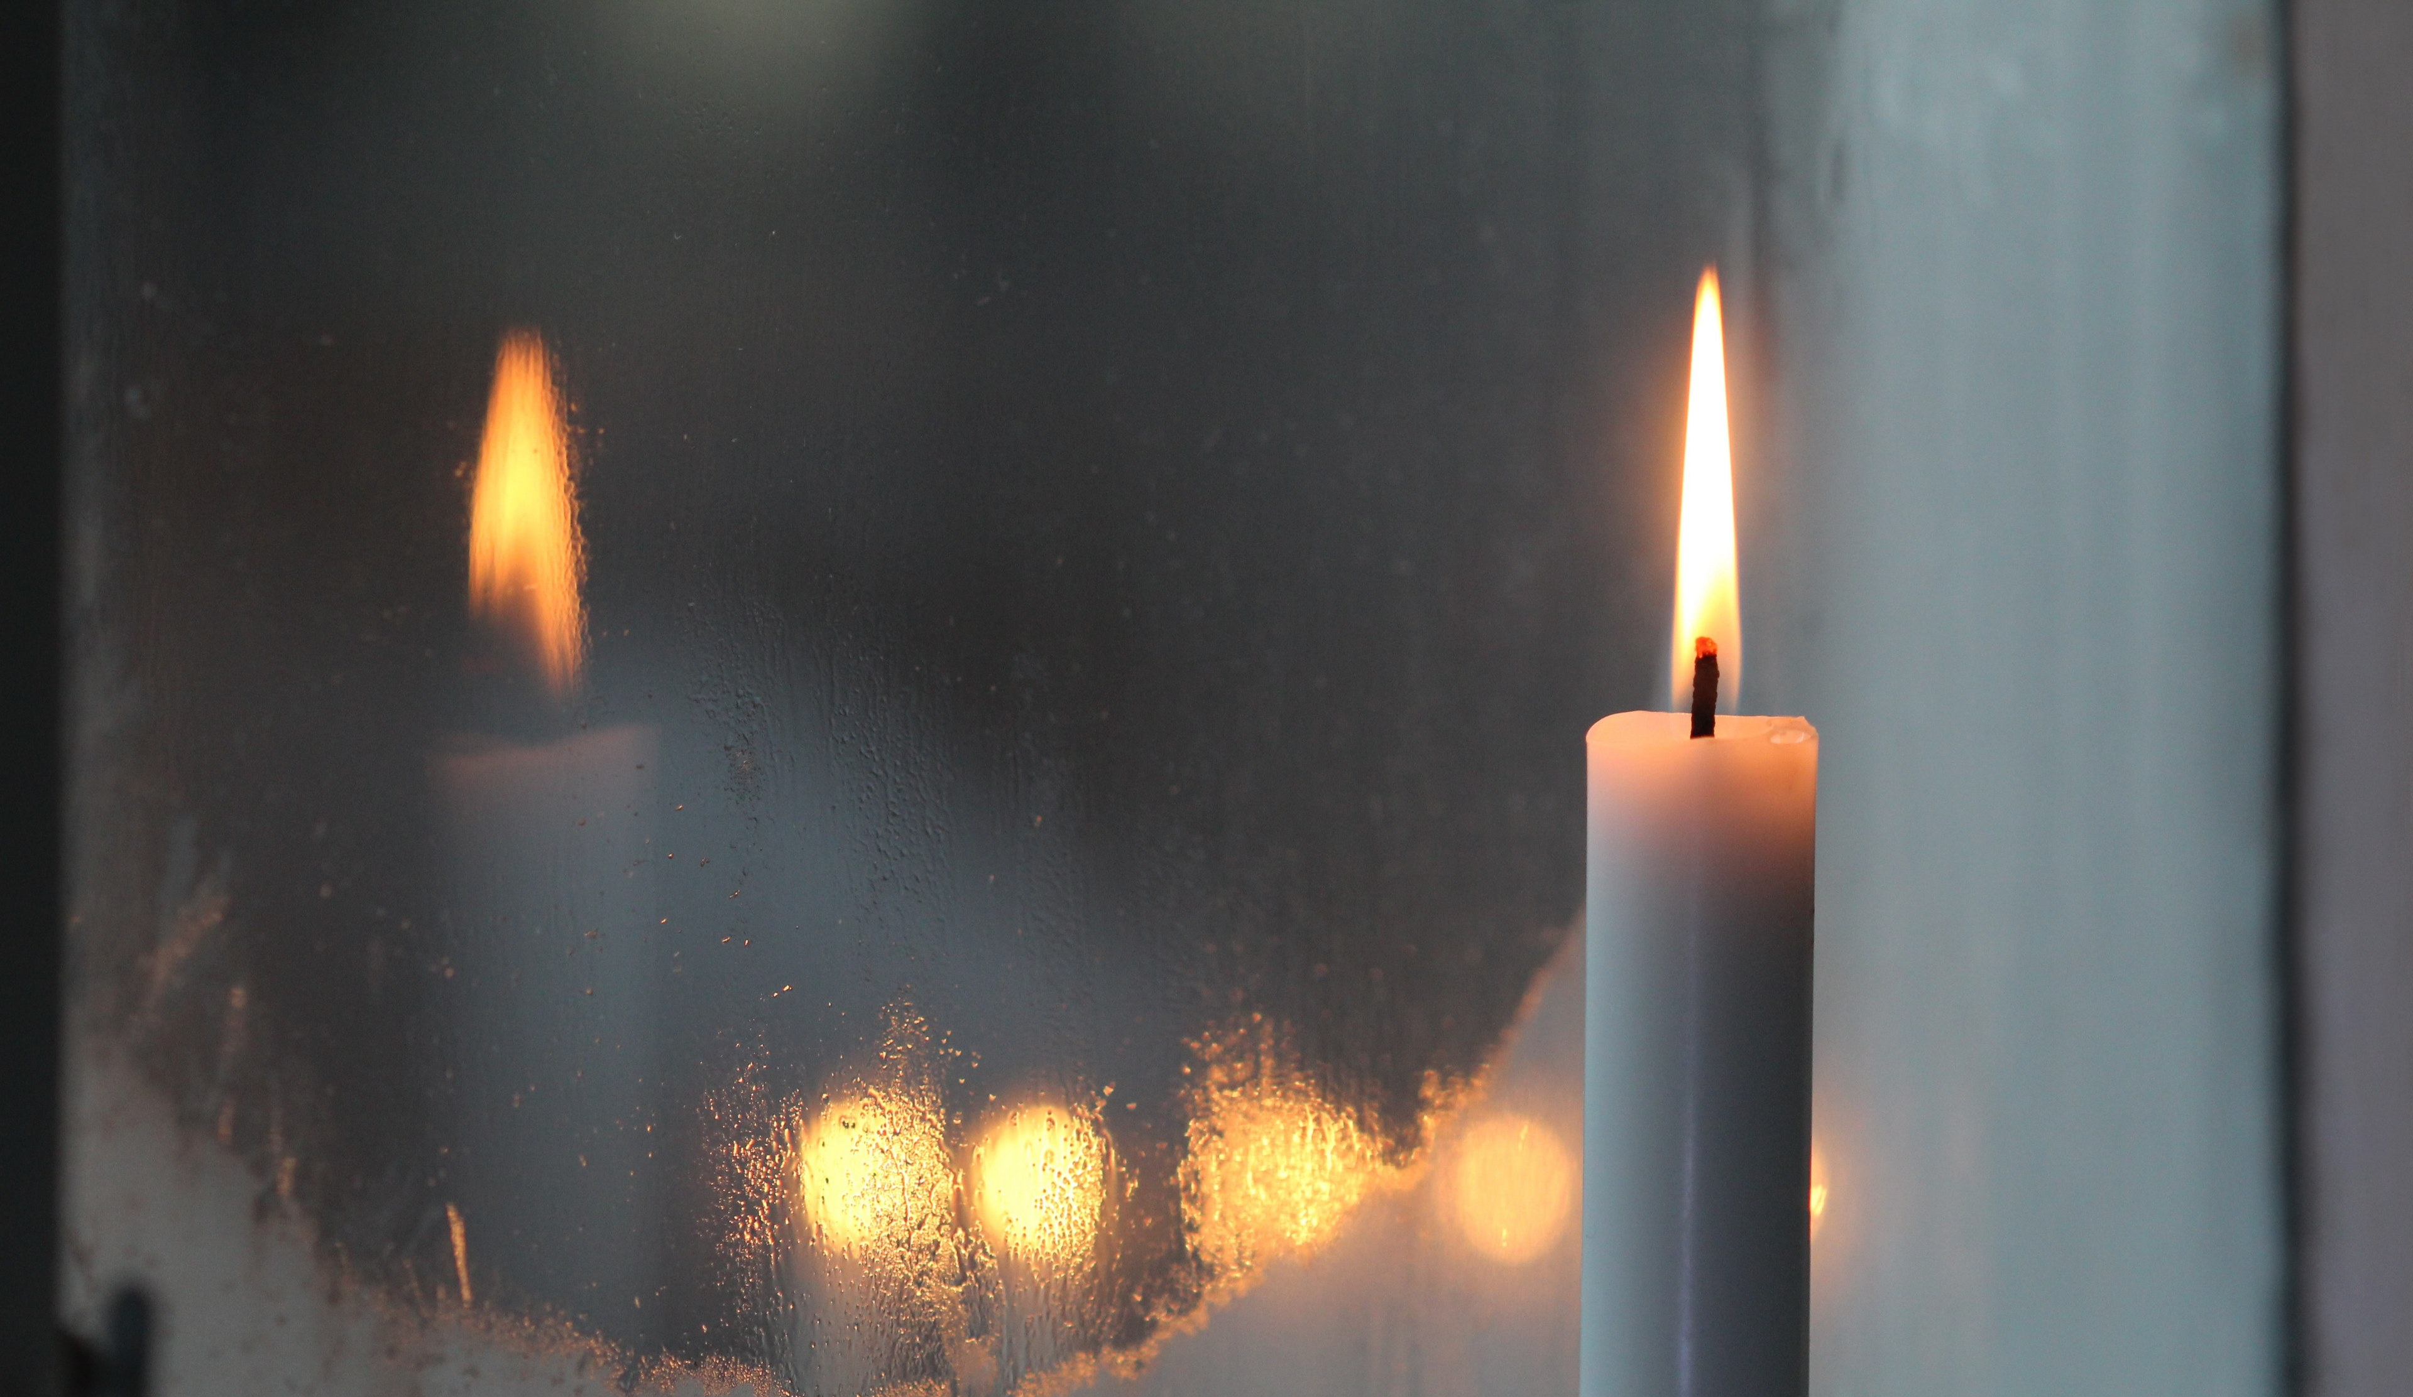

Anticipating, Longing, Waiting, Preparing...
_____

1. What distractions might keep you from preparing your heart and mind for this season? How can you make room in your life and become more present to this season?
2. Name the ways you need a “fresh entrance” of Christ in your life.

Read Matthew 25:1-13 (the Ten Virgins), Matthew 26:40 + Luke 22:45

Something to ponder...
Our spiritual life depends on His perpetual coming to us and our openness to receive. Every time a channel is made for Him, He comes; every time our hearts are open to Him, He enters, bringing a fresh gift of His very life, and on that life we depend. -Evelyn Underhill

Reflection prompts...
- What was highlighted to you from these passages?
- How does what was highlighted to you apply to your life in this moment?

Prayer prompts...
'Open my heart to receive the fullness of this gift, God...'

THE SECOND REFLECTION
Faith and Hope...
_____
…Faith is the first step to the journey forward
…Faith is believing in what is not seen
...Hope is being open and curious about the unfolding of your life
...Hope is a posture for new possibilities and God's presence with you

Read Luke 1:46-55 (Mary is the example)

Something to ponder...
We can look to Mary as our example of faith and hope, believing that the impossible is possible through our Creator. Her example of faithful perseverance in doing the will of God are a source of courage and hope for all of us.

Reflection prompts...
- As God looks throughout the whole earth, how does He find your heart? What hopes are living inside of you?
- As you reflect, do you sense any invitations from God about something you cannot see?

Prayer prompt...
'Make room in my heart for faith and hope, Jesus...'
When we live with hope we do not get tangled up with concerns for how our wishes will be fulfilled. So, too, our prayers are not directed toward the gift but toward the One who gives it... Hope is based on the premise that the other gives only what is good. Hope includes an openness by which you wait for the promise to come through, even though you never know when, where, or how this might happen. -Henri Nouwen

THE THIRD REFLECTION
Humility
_____
...Humility is understanding who you are in light of who God is
...Humility is being willing to listen and hear
Read Isaiah 57:15; Psalm 51:17; James 4:6

Something to ponder...
The Shepherds are examples for humility. Despite the fact that David was known to be the shepherd king and the 23rd Psalm calls God our Shepherd, shepherds lived on the margins of society. They were dirty, smelly, etc... Yet God chose them on that night to reveal His glory and allow them to see the Christ child.

Reflection prompts...
- In what ways do you identify with the shepherds?
- What can you learn from the humility of the shepherds?

Prayer prompt...
'I surrender my ego at your feet, Jesus...'

THE FOURTH REFLECTION
Surrender
_____
...Surrender is letting go of what we are sure of
...Surrender is deferring to another

Something to ponder...
Joseph, the earthly father of Jesus, is the example. He was able to surrender his plans for a first born child to God’s will. He was willing also to surrender to the angel and Mary to work out the disgrace the family might have experienced.

Reflection prompts...
- Do you sense any invitations from God asking you to surrender anything to Him that you don’t fully understand?
- As you reflect, can you name what you are sensing you might need to surrender or let go?

Prayer Prompt...
'Jesus, give me the capacity to let go of my grip on certain outcomes...'

THE FIFTH REFLECTION
Desperation
_____
...Desperation is having an urgent need or desire for something
...Desperation is longing for something so badly, willing to go another direction to find or have it

Read Matthew 2:1-12

Something to ponder...
The Wise Men are the example. No matter their rank in life, they were desperate to find the source and reason for the Star appearing in the sky. They were desperate to reach their destination and God was desperate to see that they did.

God went to great length to allow the Wise Men to find the Christ child. Jupiter, the King Planet, comes in close conjunction with Regulus, the king star. Then a triple conjunction happened in the constellation of Leo (Lion) when as Jupiter was crowning Regulus, Virgo rose behind Leo. Jupiter then rendezvous with Venus, the mother planet, thus producing the brightest star ever seen by man. The wise men who were astrologers concluded that a King had been born in Judah. This detail of showing the tribe of Judah and a virgin birth within the stars shows the extent that God will go to allow people seeking Him to find Him. Because the wise men were Gentile, this also showed God’s intent in including all peoples into this story for humanity.

Reflection prompts...
- Name the ways you are grateful for being included in this story.
- Reflect on how desperate you are for creating space for God to enter your life this season in new ways.

Prayer Prompt...
'God, help me connect to my inner desperation and longing for you as a pathway to deeper connection with you...'

THE SIXTH REFLECTION
Desire
_____
Sometimes the stale quality of our spiritual life is due to our lack of awareness of our “desire.” We learn to live from someplace else just to survive. Yet, when we get in touch with our longings and desires, we allow ourselves to know and be known by God.

Something to ponder...
Jesus is…”the desire of all nations” Haggai 2:7
He satisfies the “desire of all nations” (all hearts) and at the core of all hearts, we long for the same thing--to be known and loved by God.
- He is the remedy for the suffering of all people (Is 52:13-15)
- He is sufficient to supply the needs of the whole world (Is 45:22)
- God has given the nations to Him (Ps 2:8)
God’s Desire with Our Desire comes together in Jesus and produces our true desire and longing...as we delight in Him—He will give us our desires. Ps 37:4

Reflection prompts...
- Name your desires and longings before God and listen for God's response to you.
Prayer Prompt...
'God, help me discover inner desires as an avenue to knowing more of you and myself...'

THE SEVENTH REFLECTION
In this final reflection, review the words below and take them in as whole:
Faith, Hope, Humility, Surrender, Desperation, and Desire

Reflection prompts...
- Reflect on how the words above connect to one another and what these words carry for you at this time.
- Bring this time to a close in whatever way feels natural to you.

Prayer Prompt...
God, my inspiration and fountain of hope, fill me to overflow with uncontainable joy and perfect peace as I trust in you. And may the power of the Holy Spirit continually surround my life (and those around me) with your super-abundance until I radiate with hope! -Romans 15:13

Adapted by Prudence Dancy 2000 | Renewed Living Ministries

